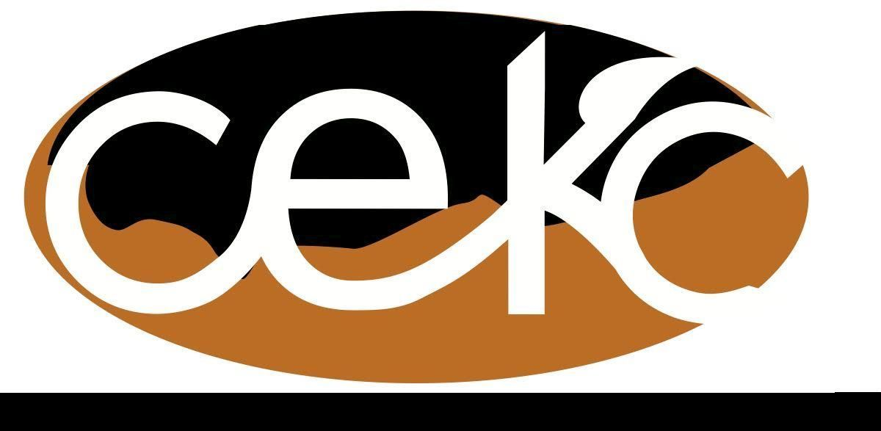
Aug. 14, 2017 Minutes
Community Enrichment Of Klickitat/Skamania County
Board Meeting July 12, 2017

Attending
Directors Jan Stewart, Karen Long, Barbara Sexton, Johanna Roe, Linda Williams,
Darla Johnston, Bruce Bolme
Guests
Debbie Pyle, Pam Hylton, Cory Eberhart, Cyndy Braelly, Leslie Naramore,
Ray Thygesen, Kimiko Atkins,

Linda Williams called the meeting to order at 10 a.m. in the Lyle Activity Center

Action Items:
The minutes from the June 2017 CEKC board meeting were approved unanimously following a motion by Barb Sexton, seconded by Karen Long. There were no corrections or additions.

The Treasurer report was presented in written form and accepted.

New Business:
- Cory Eberhart - Thank you to CEKC without which the LPFm radio station in Goldendale wouldn't exist. Has an opportunity to purchase another radio out of The Dallas but needs funding help. It broadcasts at a much high wattage thereby covering most of the Gorge. All agreed it would be an excellent opportunity for the area but there are many questions that Cory didn't have an answer for at this time. She was asked to put together a business plan with definitive dollar amounts with funding possibilities and sustainability plans. CEKC can not be the 501(c)3 for this new station. Only one station per non-profit. This means CEKC would have no control over the content. More discussion after presentation of Cory’s plan.
- Ray Thygesen - Trout Lake Care - They have spent the grant money we awarded them and would like to apply for some additional funds. They have another new coordinator that receives $700-$1000/month. Ray will put together a presentation for our review.
- Kimiko Atkins- Junior Chamber of Commerce- they would like to break away from the National organization and come in under CEKC. Had no definitive mission statement. Would need a new name. They have worked with other community org.’s but there may have been some issues. Why? Personality issues or organizational issues? CEKC needs to know more. Linda will contact Elaynna James for additional information.

Old Business:
- Notebook with forms ready at next meeting. Johanna to put forms on Website. Thank you Johanna.
- Lyle Community Council restart is progressing. They have a new committee and the first meeting is Sept.25. They will have a facilitator to help them. Dept. of Commerce would like to se CEKC do community workshops once month.
- White Salmon Grange- New floor is done and looks great. They are working on prioritizing their wish list of further remodels/upgrades. They will be installing WIFI and will possibly do educational programs.
- The White Salmon Farmers Market will move there in Sept. to extend their season.
- White Salmon Gleaners are still unstable and the Grange has declined to be associated with them

Committee Reports
Senior Services - the local Area on Aging is looking for representation. If interested contact Sharon Carter.
- Skamania EDA - looking for local business to populate 3 pieces of property of varying sizes but are good locations.
- Klickitat EDA- Richard unable to attend but said 10 year Strategic Planning is progressing.
- WSU Extension- N/A
- Karen Long -There will be a regional Asset Building Summit/Neighborhood Partnerships offered in Hood River at the Community college on September 12th from 11-1. Skamania and Klickitat County providers are welcome to participate.
- WABC’s Statewide Conference - Oct. 17 in Snoqualmie. If you plan on going you should register early.
- Communications - N/A
- Food Security -the conference was proposed to call attention to the WA. side of this issue. Washington is not part of the regional food bank. Bruce is looking into this.
- Rural Family and Business Preparedness Expo - is progressing. Have confirmed the use of Goldendale Grange for the Oct. 21 event.
- Broadband - N/A

Community Reports -
- Underwood- Darla Johnston provided an update on the Underwood Community Center. Car show went well. The change over is progressing but not complete.
- Lyle- Barbara Sexton reported there was no August OLESS meeting.
- Klickitat- Senior meals are going well. KLASAC is offering some substance abuse and mental health counseling opportunities on Wednesday from 1:00-1:30 PM. Trail Run planning is ongoing for the Nov. 4 event.

Next meeting Sept. 11, 2017 at Lyle Activity Center. There will be a baby shower (open to all including guys) for Karen Long following the meeting with lunch provided. There will be a planning/brainstorming session the afternoon.

