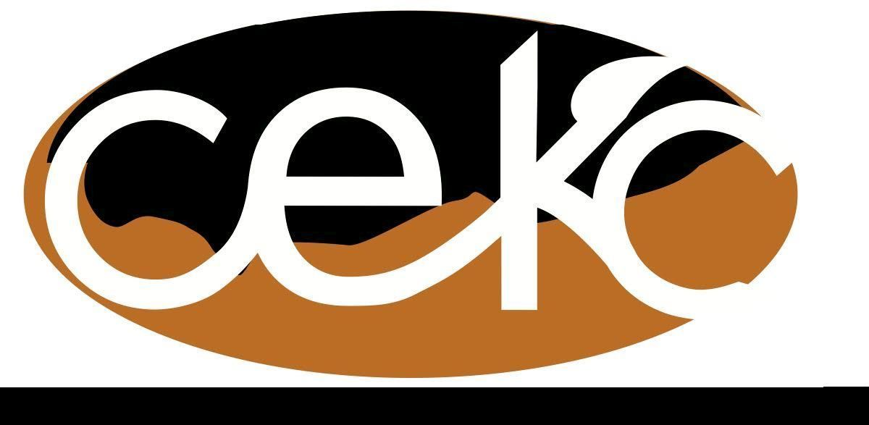
Oct.9, 2017 Minutes
Community Enrichment Of Klickitat/Skamania County (draft)
Board Meeting July 12, 2017

Attending
Directors Jan Stewart, Barbara Sexton, Johanna Roe,Brian Wanless, Darla Johnston, Bruce Bolme
Guests
Pam Hylton, Cindy Bradley, Debbie Pyle, Vicki Pfeiffer

Brian Wanless called the meeting to order at 10 a.m. in the Lyle Activity Center

Action Items:
The minutes from the September 2017 CEKC board meeting were approved unanimously following a motion by Johanna Roe, seconded by Darla Johnson. There were no corrections or additions.
The Treasurer report was presented in written form and approved unanimously following a motion by Jan Stewart, seconded by Johanna Roe.

Old Business:
- Brian still trying to resolve the Georgeville garden acct.
- Agora is pretty much defunct at this point

Committee Reports
- Senior Services - Sharon unable to attend, nothing new.
- Skamania EDA - Cindy Bradley
- Washinton Investment Board is trying to figure out the monetary impact of the fires for 2016-20117 to offer some kind of financial aid. Some short term loan if it can be proved to be fire related.
- Working with the school metal and auto body shops to set up some training similar to internships
- Some of EDC will moving to the Port, sharing space and a admin employee.
- Klickitat EDA- Richard not in attendance
- WSU Extension- Hannah not in attendance
- WABC’s Statewide Conference - Oct. 17 in Snoqualmie. Stephanie would really like to see someone from our group attend
- Communications - N/A
- Rural Family and Business Preparedness Expo - is progressing. Have confirmed the use of Goldendale Grange for the Oct. 21 event.
- Food Security - Nothing new but is doing good work.
- Asset Building Workshop- Johanna attended, was OK. Housing, Child Care, and Health Care were the hot topics.
- Goldendale Family Expo went very well, with about 30 attending but there was a lot of engagement by public. Could we partner with EDC with something on the financial impacts of disasters?
- White Salmon Farmers Market and Gleaners-
- White Salmon Gleaners meed to close their account.
- White Salmon Market has moved into the Grange, will go as long as possible.
LPFM - KGBD’s license will be up in September 2018. KDOA can’t sell their license yet. Plans are still in the works for CEKC to acquire KDOA’s license. There will need to be some equipment purchased. Initial outlay should be between 10K-12K. This station may no the 100% volunteer. Yearly costs should be about $1400. Brian to find out if they can operate in a power outage? Could Horizons communities help with some funding?

- Community Reports -
- Underwood-
- The change over should be complete by Nov. 1 when Parks and Recreation will sign contact with the county and will take over responsibility. Must bring in 15K/year to retain deed.
- Tech Soup, a non-profit software provider for non-profits, purchased Grant Station for UCC
- Lyle-
- Another meeting on reviving the Community Council- went well w/about 20 in attendance including David Sauter, Linda and some native representatives. No firm decision to reformat probably.
- Lyle Celebration Center yard sale brought in almost 10K.
- Klickitat-
- Senior meals are going well.
- Trail Run planning is ongoing for the Nov. 4 event. Linda Isaacson want to offer 2 small scholarships from gross intake.
- Home for Heroes went very well. This was the 7th year.

New Business
- Vicki Pfeiffer- just an update. Plans are on hold for awhile. Personal problems that have to be addressed. Hopefully will be going by spring.

Notebook with forms ready at next meeting. Johanna is having trouble getting forms on website, Might have to talk about Dropbox.

Next meeting Nov.13, 2017 at Lyle Activity Center.

